DBMS Project  
Football

Premiere League



**Guided by: -**

**Dr. Radhakrishna Rambola**

Our Team: -

Akshit Naithani (B208)

Vrishin Jain (B235)

Vansh Mistry (B223)

Meet Desai (B238)

Introduction

League databases are required to keep track of the matches happened which help in the analysis done by the clubs for their new season or next matches. It also helps the club to understand where they stand in the league and what needs to be done to compete further in the seasons to come. Analysis of player can also be done to see their value for the club, whether to buy, sell or renew their contracts. If a player performs well in the league, then he might be approached by different clubs while his existing club tries hard to keep the player. The opposite happens when he does not perform well in the league. This database is also beneficial to the clubs to see and analyse what happened the last time they went up against a certain team and change or keep their original tactics that was used against their rivals last time out. This also helps them in the Champions League where they can see similar tactical clubs and predict the way they will play so they could easily win their games.

Tables Used in the Database

Teams –

ID number

PK Name varchar2()

AK Home_Stadium varchar2()

Players –

Name varchar2(30)

PK Player_Number number

DOB date

Position varchar2(20)

Nationality varchar2(20)

FK Team varchar2(3)

FK references Team(Name)

Stats –

PK player_number number

name varchar2(30)

goals number

assists number

appearances number

yellow_cards number

red_cards number

FK Team varchar2(30)

FK references Teams(Name)

Referees-

PK ID number

AK Name varchar2(30)

Matches number

Red_Cards number

Yellow_Cards numer

Fixtures –

FK1 Home varchar2(30)

FK2 Away varchar2(30)

Home_Score number

Away_Score number

FK3 Home_Statdum varchar2(30)

Matchday number

FK4 Referee varchar2(30)

FK1 references Teams(Name)

FK2 references Teams(Name)

FK3 references Teams(Home_Stadium)

FK references Referees(Name)

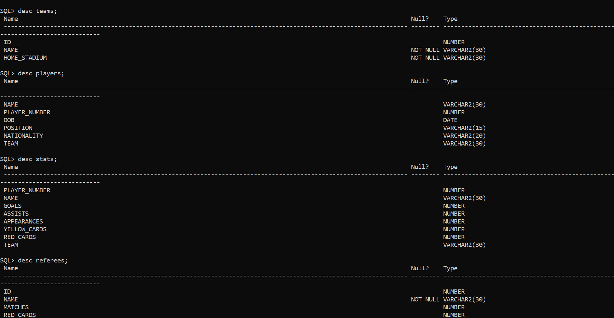

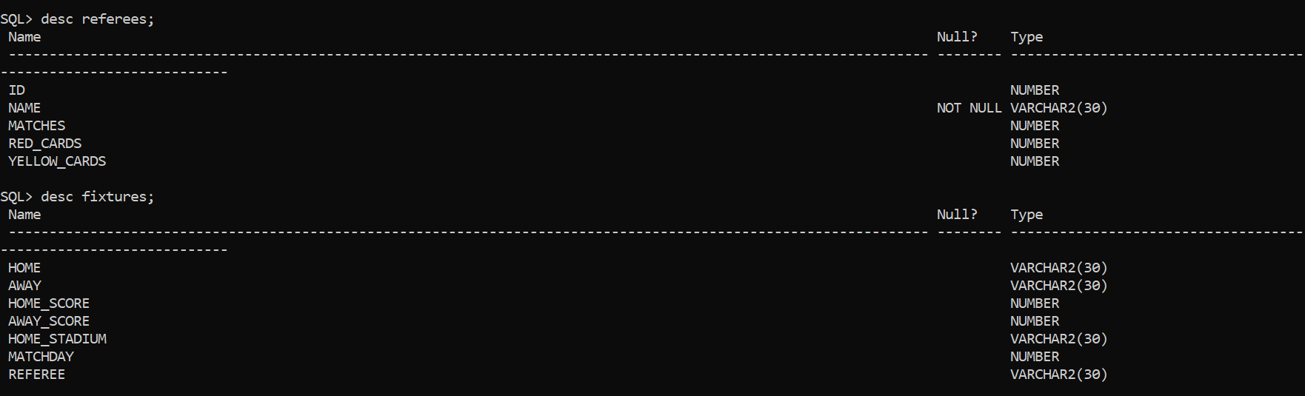

ER - Diagram

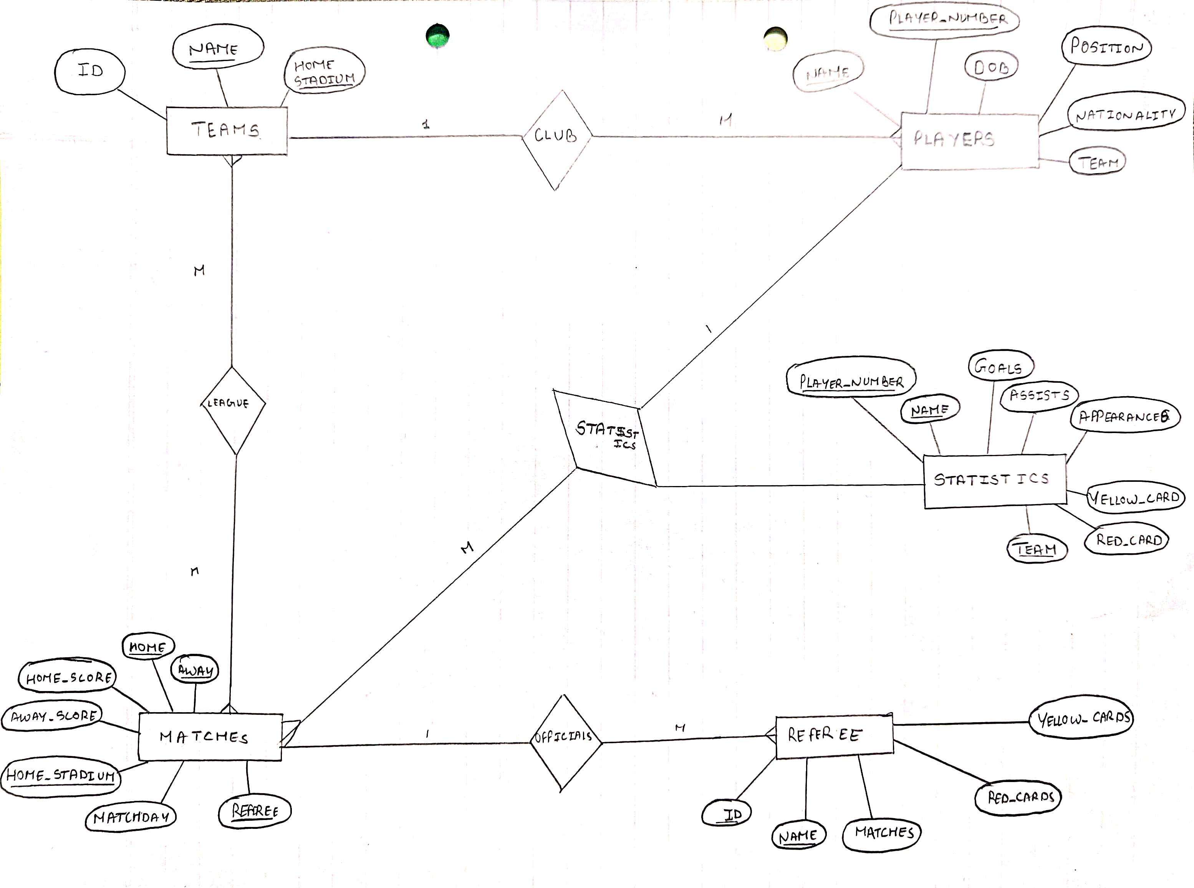

Data Entries

Teams -

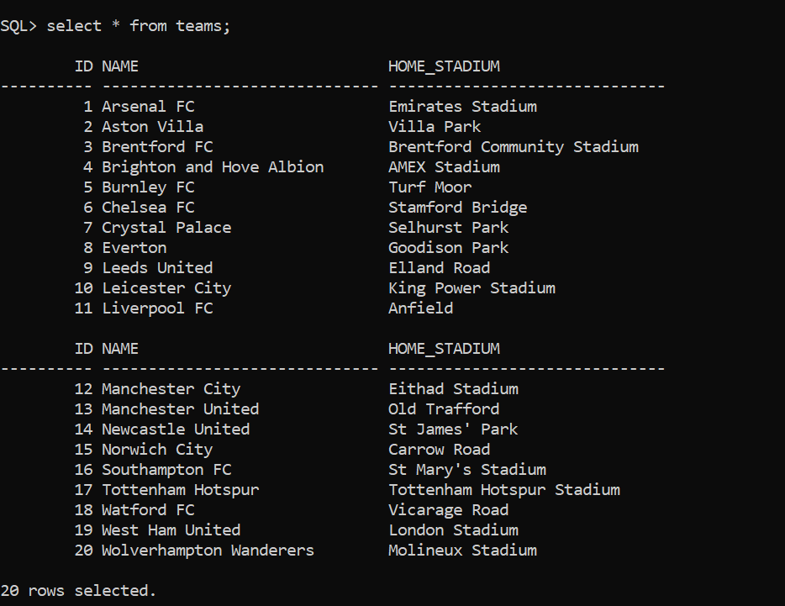

Players -

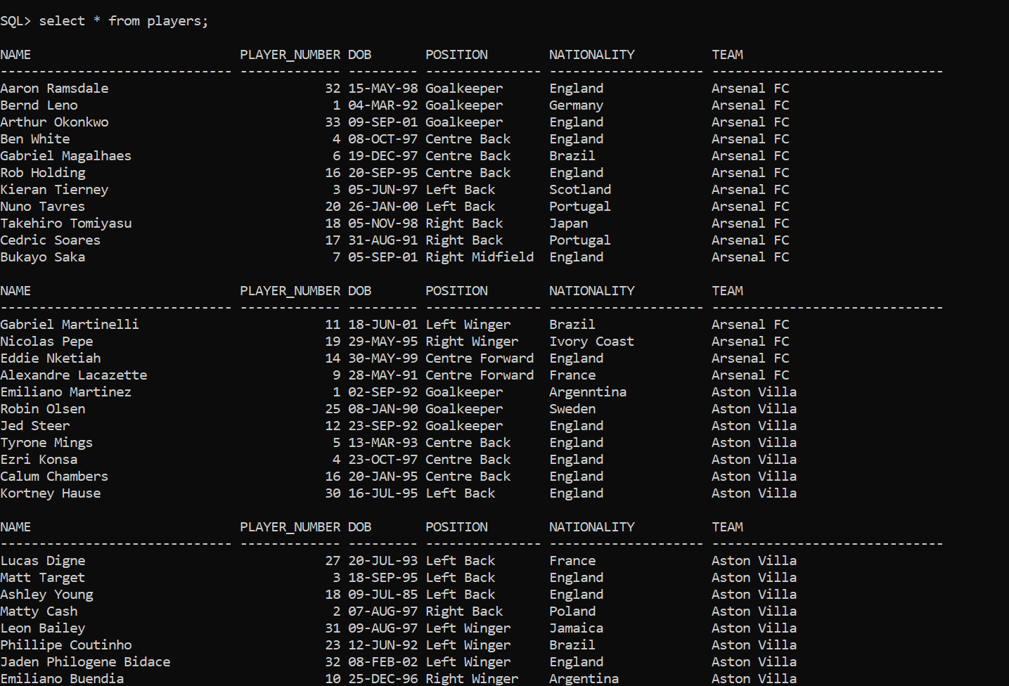

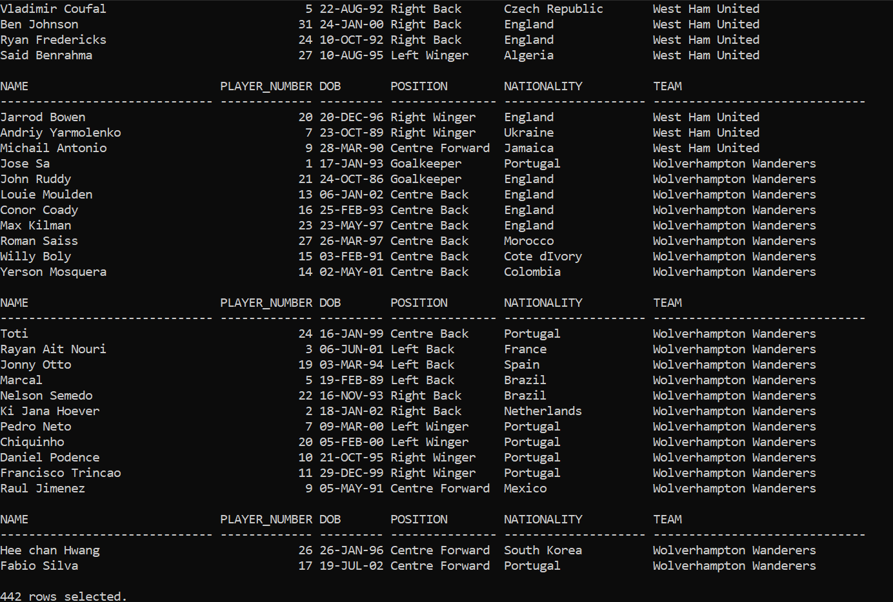

Stats –

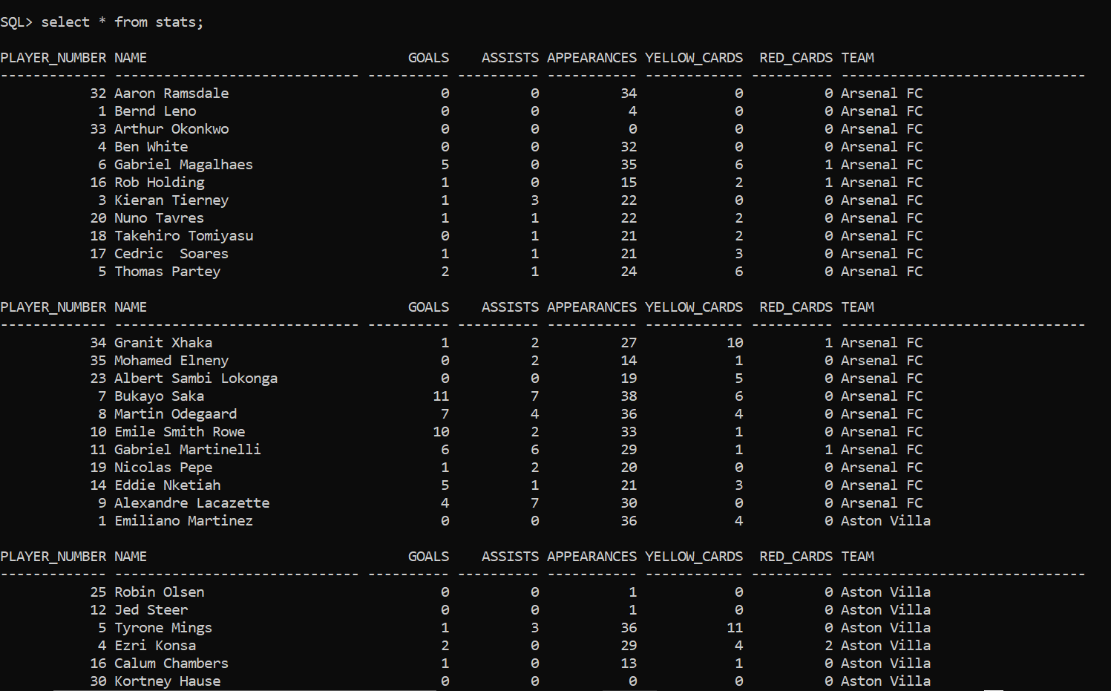

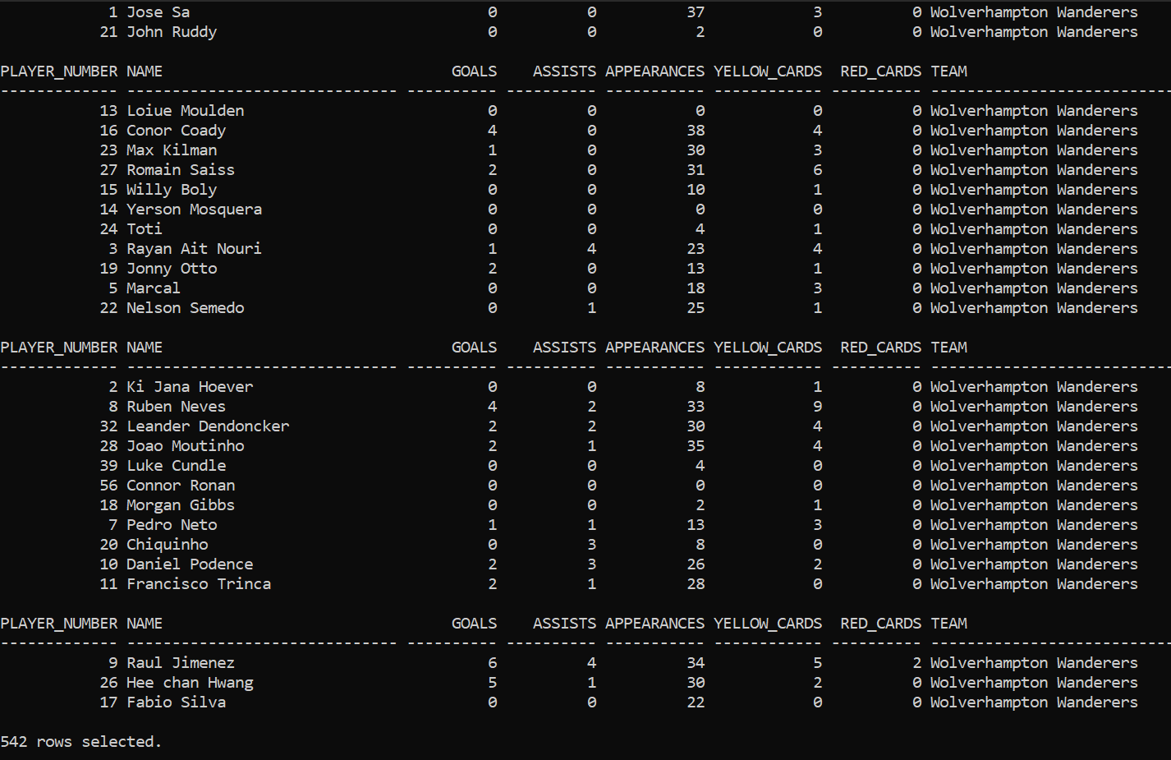

Referees –

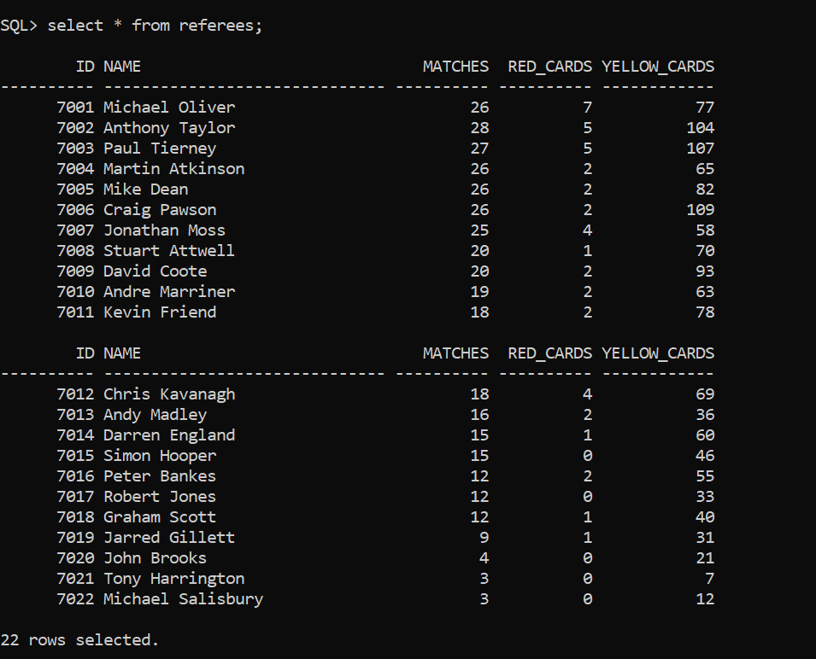

Fixtures –

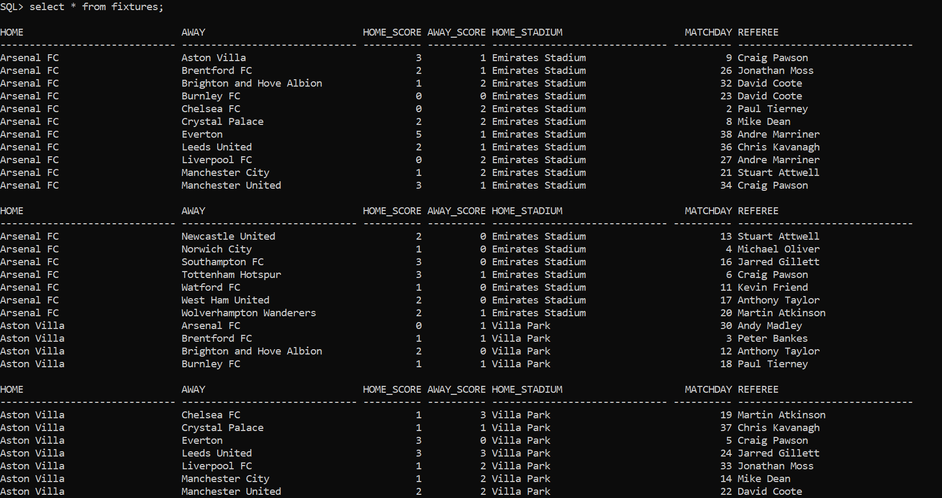

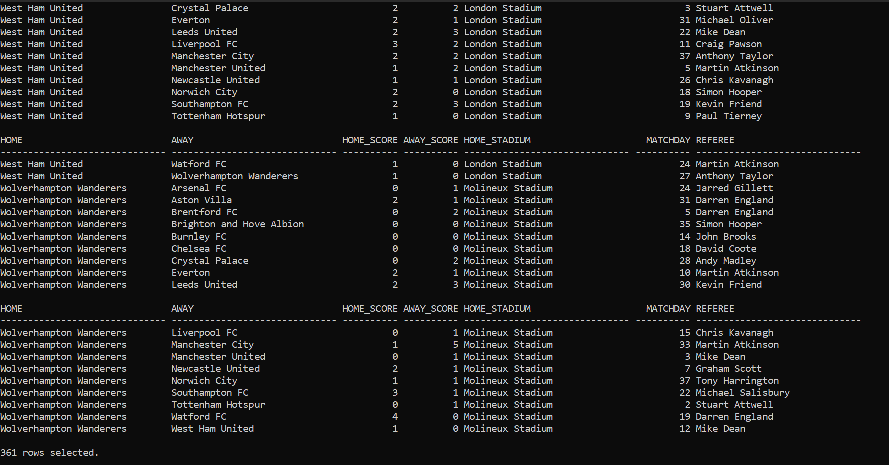

SQL Queries

Q1. Players With Goals Greater Than 10

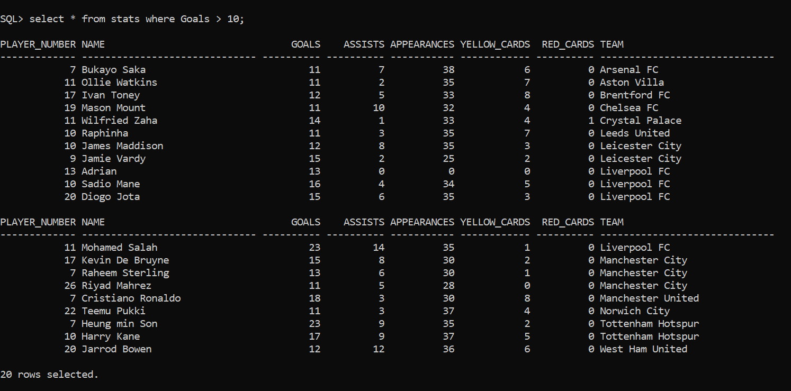

Q2. Stats Of All Players From A Manchester City

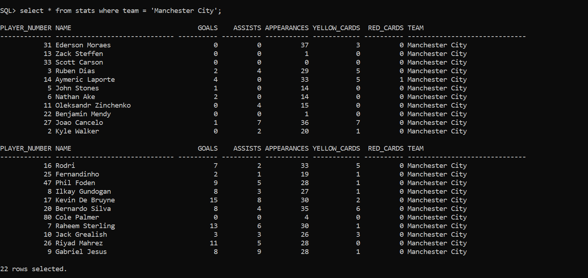

Q3. Players from Arsenal in Descending Order by Goals

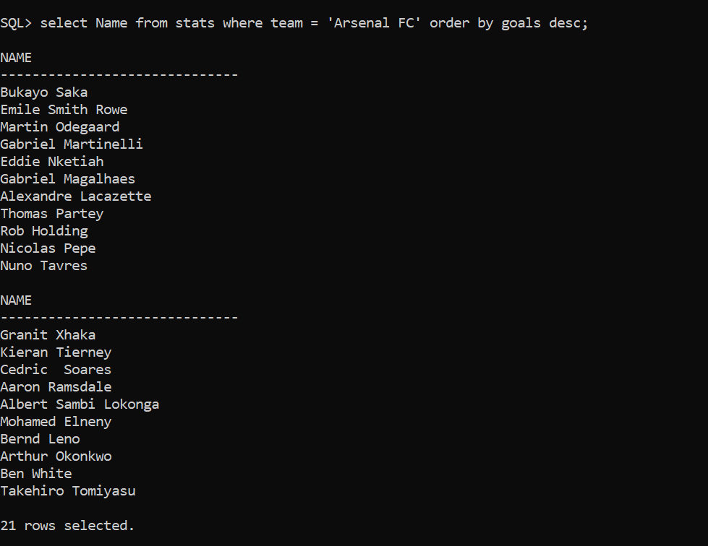

Q4. Teams Ending With FC

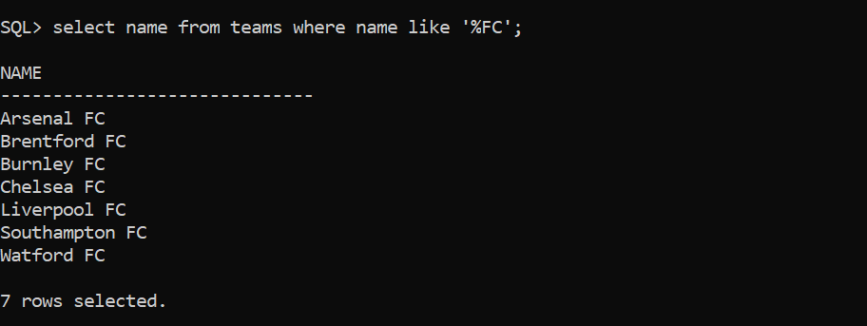

Q5. Show Highest Number Of Goals Scored By A Player In The League

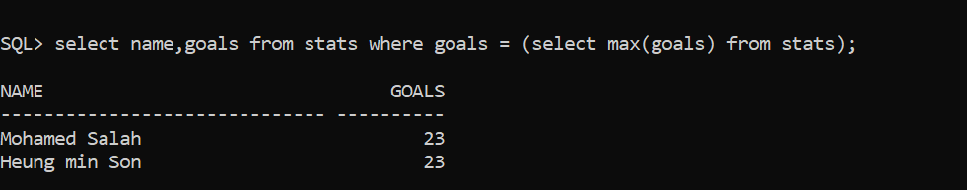

Relational Algebra Queries

Q1. Show Name of players from a team name ‘Everton’

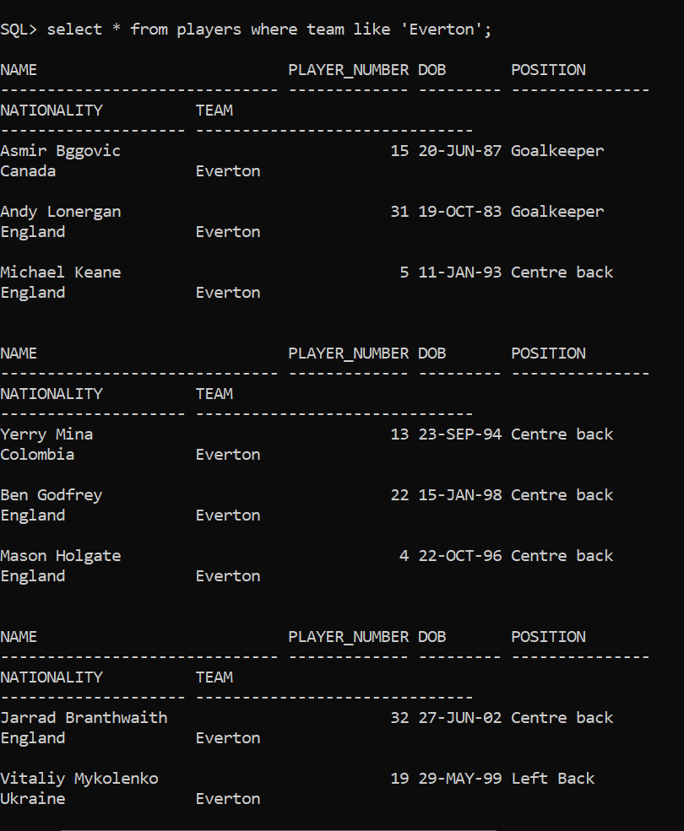

Q2. Show name of Referees with the number of red cards

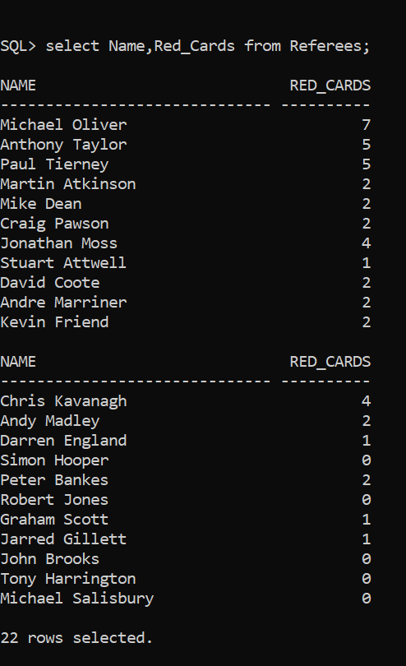

Q3. Players with their Name, Player number and number of Goals they scored

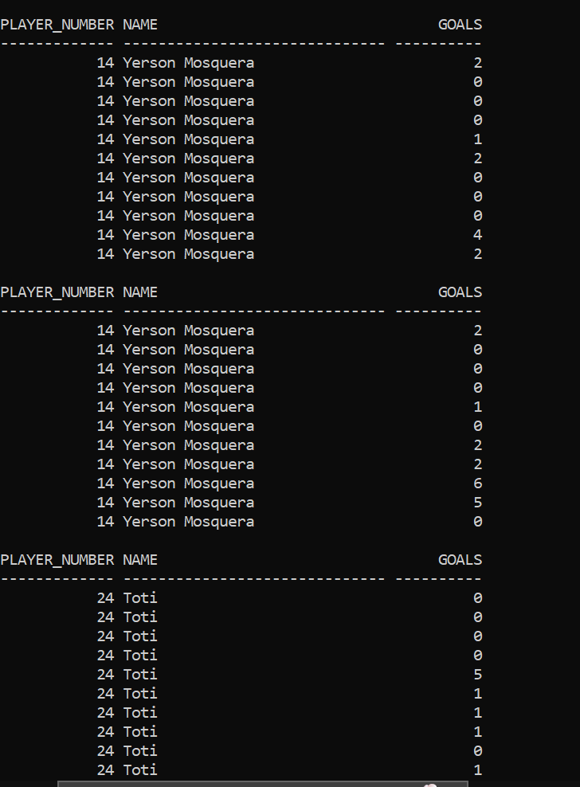

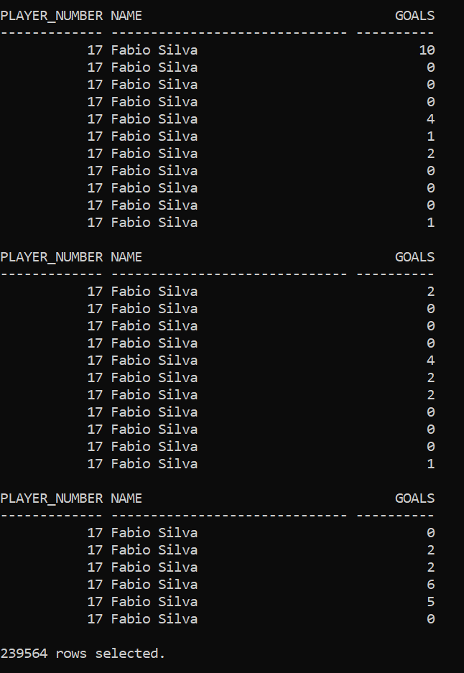

References –

<https://www.javatpoint.com/dbms-relational-algebra>

<https://www.guru99.com/relational-algebra-dbms.html>

<https://www.w3schools.com/sql/default.asp>

<https://www.transfermarkt.co.in/premier-league/startseite/wettbewerb/GB1/plus/?saison_id=2021>

<https://stackoverflow.com/questions/10839856/using-sql-loader-in-oracle-to-import-csv-file>